Threshold changes

removeHair(img_rgb, img_gray, kernel_size=5, threshold=0)

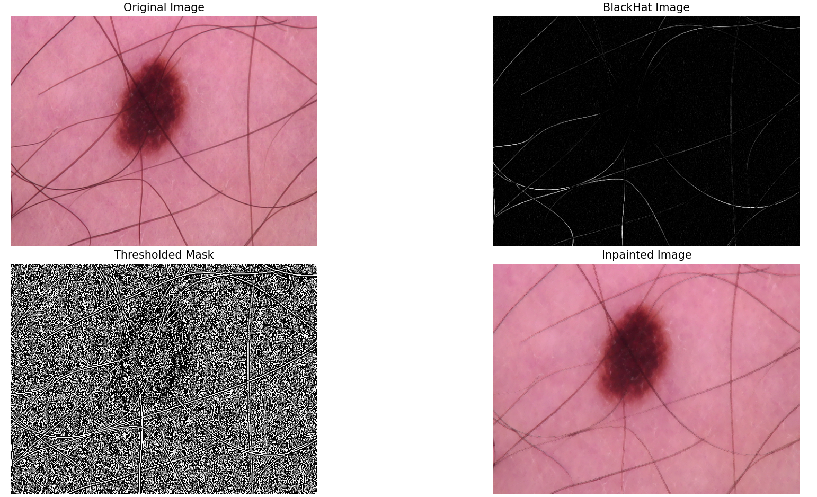

removeHair(img_rgb, img_gray, kernel_size=5, threshold=3)

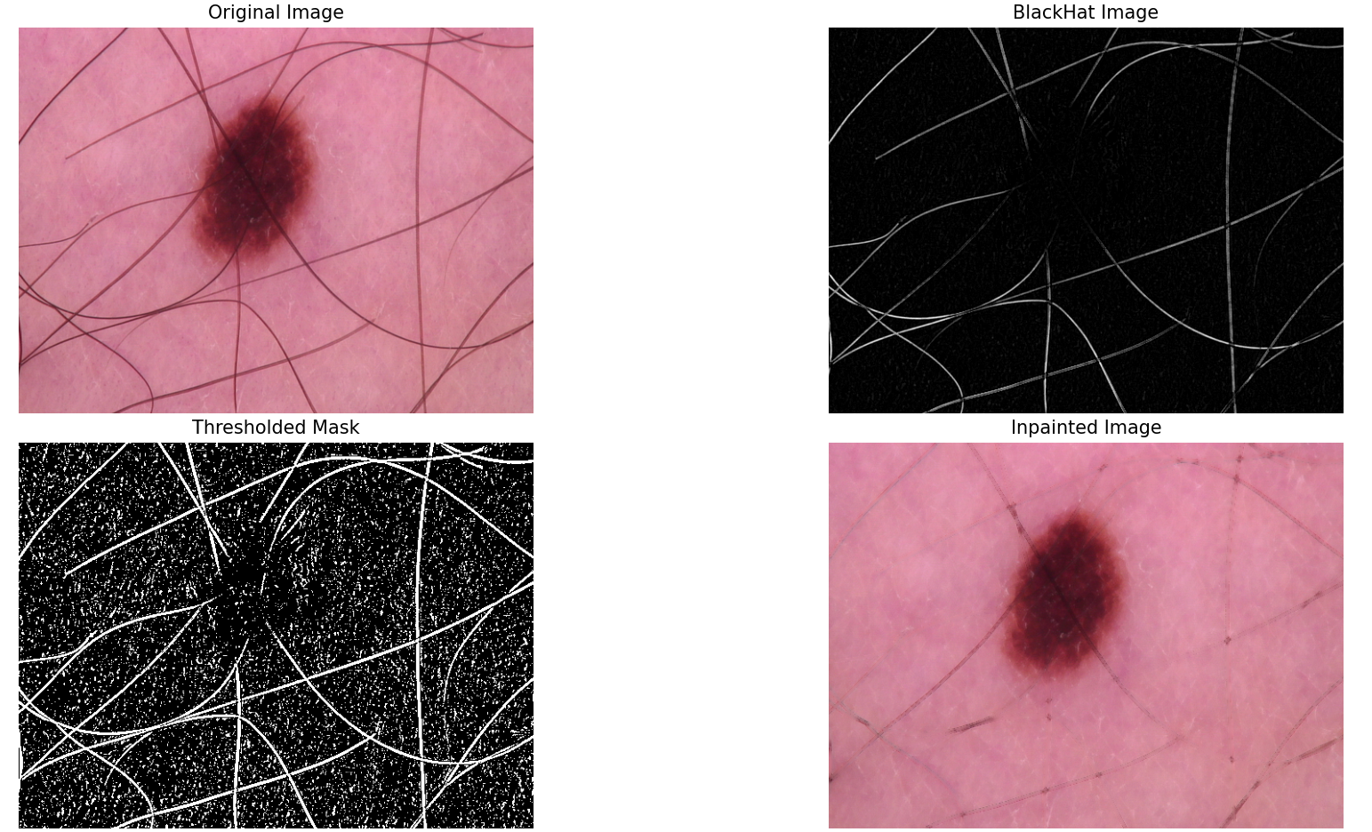

removeHair(img_rgb, img_gray, kernel_size=5, threshold=20)

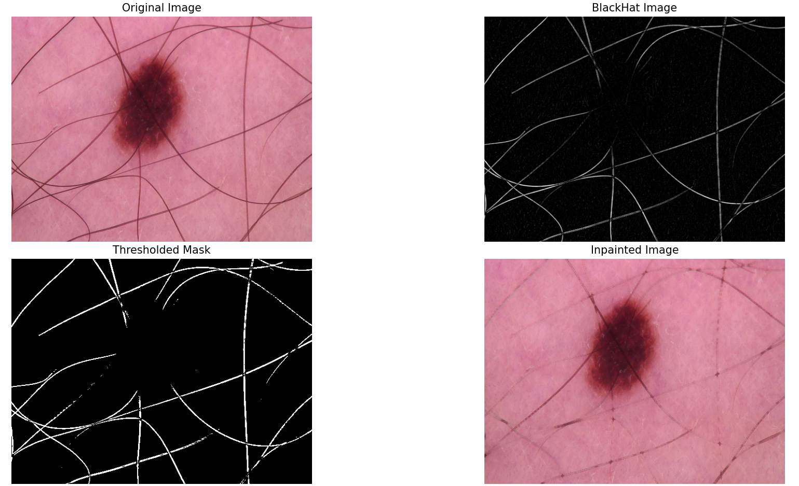

removeHair(img_rgb, img_gray, kernel_size=5, threshold=50)

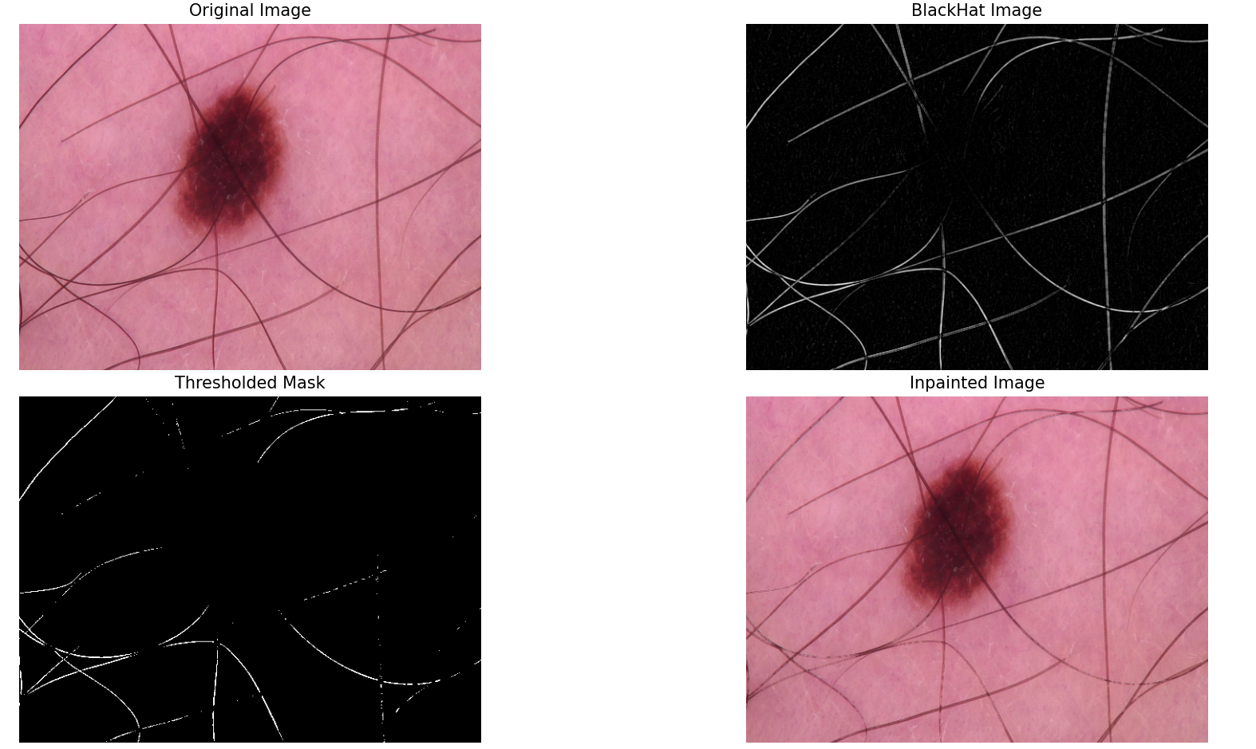

Kernel Size changes

removeHair(img_rgb, img_gray, kernel_size=5, threshold=10)

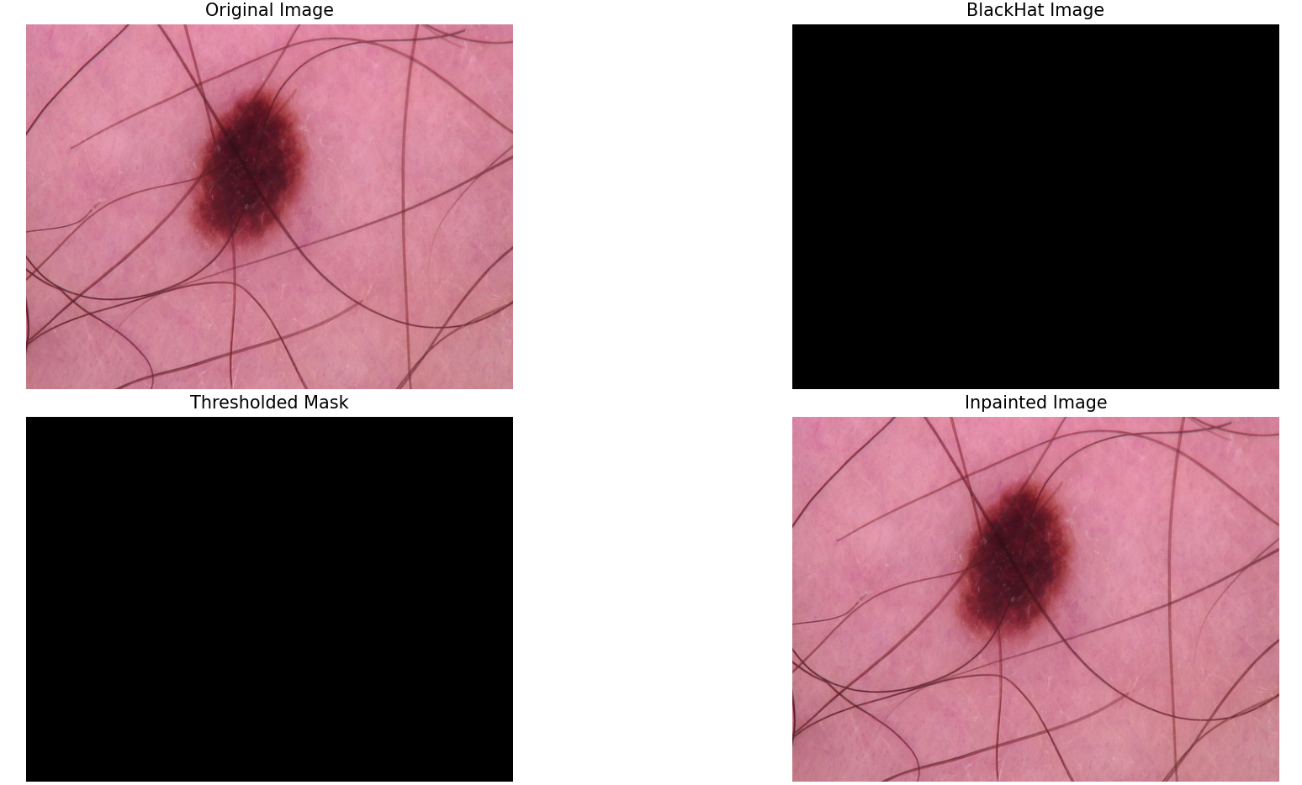

removeHair(img_rgb, img_gray, kernel_size=7, threshold=10)

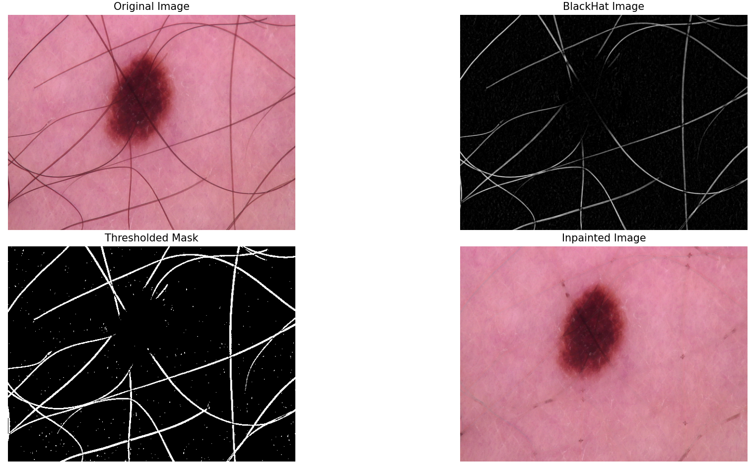

removeHair(img_rgb, img_gray, kernel_size=10, threshold=10)

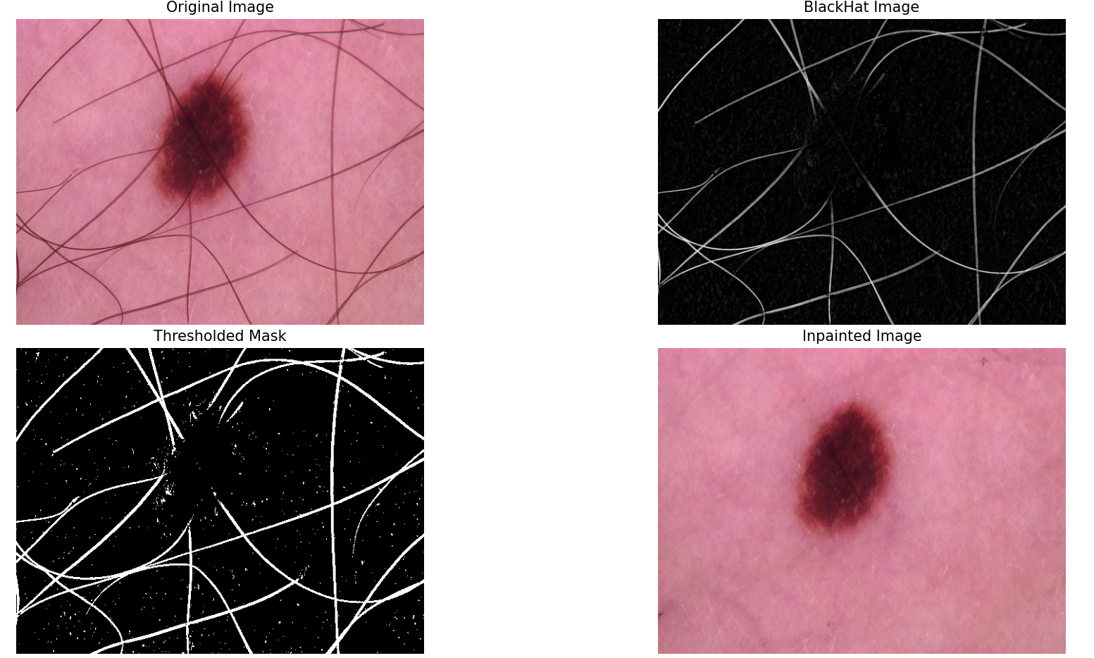

removeHair(img_rgb, img_gray, kernel_size=25, threshold=10)

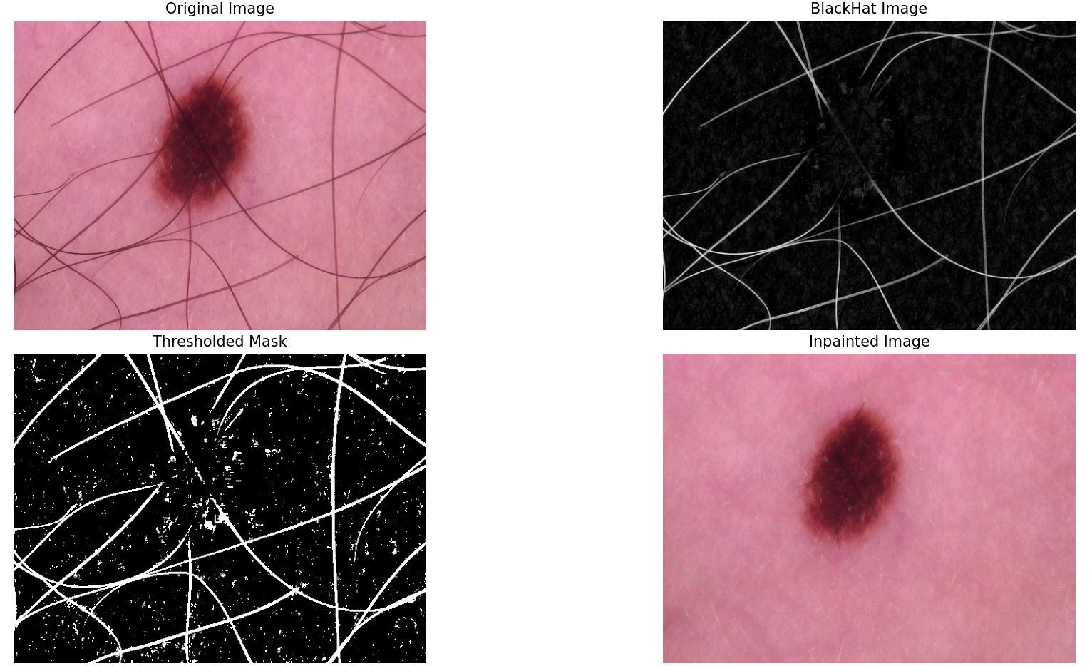

removeHair(img_rgb, img_gray, kernel_size=50, threshold=10)

